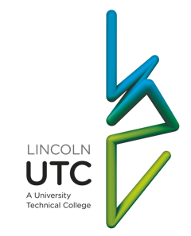

Project work at Lincoln UTC

Academic success and qualifications are important. Good GCSE, BTEC and A Level results open doors for our students and are the key to their future success in industry or at university.
We are not unusual in believing this or in doing everything possible to prepare our students for examination success. If our students went to an ‘ordinary’ school their teachers would almost certainly hold a similar view.
Where we differ from ‘ordinary’ schools is the emphasis we place on providing students with the opportunities to develop the skills that will set them apart from other young people, the skills that will help them succeed in industry and at university. Everything that we do at the UTC is focused on helping students acquire these skills, behaviours and traits.
Curious | Analytical
Motivated | Big-picture
Organised | Creative
Independent | Ambitious
Collaborative | Resilient

The project programme is a key part of our skill development strategy. Students have two triple lessons working on projects every week.
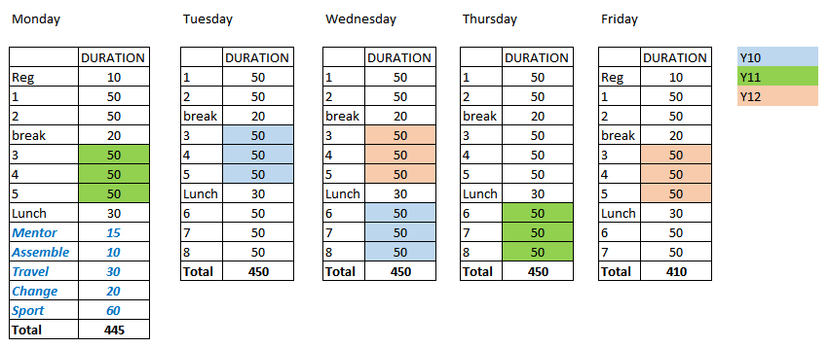
The problem with teenagers?

Teenagers sometimes come in for a lot of ‘bad press’. There is a general perception that teenagers have short attention spans, get bored easily and give up quickly. Whilst it is dangerous to generalise, there may be some truth in this. If this is true, it is probably unfair to blame the young people. The fault probably lies with our education system.
A GCSE student will have been in school for eleven years. For eleven years they will have had their days planned for them. They will have been told what to do and when to do it. Their school day will have been broken down into one-hour lessons and the content of each of these lessons will have been decided and planned by the teacher. Most ‘good’ teachers go one stage further and break each lesson down into smaller, shorter chunks. Received wisdom is that a good lesson typically has a starter activity, one or two main learning tasks and a plenary activity. Throughout most of their time in school students will have had their learning delivered in twenty-minute instalments.
A ‘good’ teacher is attentive and is quick to offer help to students who appear to be stuck or struggling. When the students make mistakes or get things wrong the ‘good’ teacher is quick to correct them, to point out the mistake and to provide the ‘right’ answers.
Is it any wonder that some students have short attention spans and limited resilience? Is it any wonder that they are needy and overly reliant on the teacher to provide them with the ‘right’ answers? If these are learned behaviours then they have been learned because we, as teachers, have spent eleven years training the students to behave in this way.
Lincoln UTC’s projects are different. The shortest of the projects will take two and a half hours (a triple lesson). Most will require the students to work on the same challenge for four consecutive project sessions, spending a total of ten hours grappling with the same problem. Students are not spoon-fed and are not told how to approach or solve the problems that they encounter. There is an expectation, in most of the projects, that the students will make mistakes and fail…that they will then reflect on and learn from these mistakes, and become more resilient as a consequence.
Projects are carefully chosen and planned to encourage independent learning (independent of the teacher) and collaborative learning. Many of the projects involve students working in teams. Most of them involve an element of creativity and creative thinking. Students are expected to plan and organise their own approaches to their work.

Lincoln UTC
The ideal student

- The ideal student is curious. He wants to make sense of the world around him. He has the capacity for awe, wonder and amazement. He wants to understand everything.

- She knows what is important to her and ‘what makes her tick’. She arrives at all lessons motivated and committed. She is an active participant in lessons. She does not rely on others (teachers) to provide her motivation.

- He has high levels of personal organisation. He plans carefully and makes good use of his time, hitting all deadlines.

- She is independent and does not regard herself as a hollow vessel waiting to be filled with the information necessary to pass her exams. She does not wait to be spoon fed. She wants to find things out for herself.

- He works well with others, listens to others and appreciates that he can learn most effectively when learning is a collaborative activity. He treats others with respect at all times.

- She is analytical in her thinking, able to construct a convincing argument for her views and opinions. She always explains her thinking and justifies her reasoning.

- He always tries to connect his learning to work done before and work that he knows is coming. He tries to link all new learning to real life contexts, to his own life experience and to academic work in other subjects.

- She is a creative thinker who is willing to ‘think outside the box’. She is happy to take risks and try new things.

- He sets ambitious targets for himself and is willing to do whatever it takes to realise these goals. He routinely reviews his progress towards these targets. He asks for feedback as part of this process.

- She isn’t afraid to get things wrong. She is resilient…always ready to ‘get back on the horse’ and try again. She learns from her mistakes, corrects all her work and responds positively to constructive criticism. She perseveres when things are tough and doesn’t give up quickly or easily.
Projects
Gas turbine re-design
Siemens in Lincoln (one of our industry partners) produce gas turbines. These gas turbines run on methane gas or on diesel. They are used across the world for generating electricity and for pumping oil and gas. These large turbines can generate a vast amount of electricity, but they also produce a vast amount of very hot exhaust gases. Most gas turbines only achieve 30% efficiency with almost 70% of the energy from the fuel escaping as heat. Working in groups, using real industry data provided by Siemens, students have to research and study turbine design and operation. They have to apply their knowledge of chemistry and physics to calculate theoretical energy output, energy losses and efficiencies. This project requires some high level mathematical skills. They are then asked to propose design modifications which could improve the efficiency by harnessing and using the energy in the hot exhaust gases. The students are expected to present their proposals and their designs, to senior staff, to governors and to senior managers from Siemens. (10 hours)
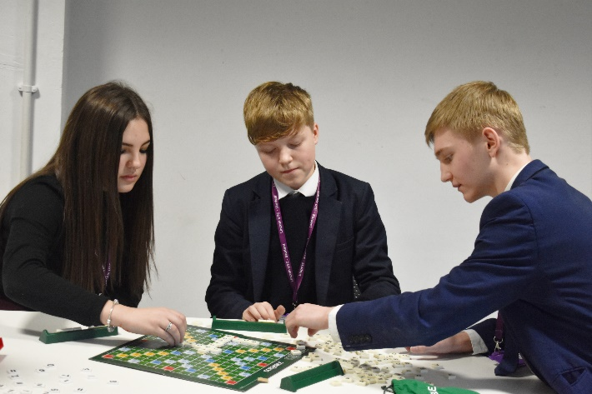
Scrabble (Number)
This project takes two triple lessons, typically 5 hours. Students start simply by playing a game of scrabble. They are then asked to design and manufacture a version of the game that is based on numbers and maths rather than letters and words. Scrabble scoring is based on the length of the word and the different points values of each letter according to the frequency of its use in the English language. Strategic positioning to use the bonus squares on the board (double word, triple letter etc.) adds to complexity and skill in the game. This scoring system cannot be simply copied for a number based game. Students are required to create the rules and the scoring systems for their games. They then make a prototype, test and refine the game. Once they have a workable game they are expected to use computer aided design and manufacturing to produce and package a finished product.

Giant Meccano
First launched in 1898, Meccano has been a perennial favourite with children across the globe allowing them to be creative in their model making whilst learning some basic principles of mechanical engineering. Lincoln UTC has created a kit of giant Meccano with M8 bolts and a range of pre-drilled steel sections up to 1.5 metres in length. Just like the child’s toy, these kits can be used to make models that tackle a variety of engineering challenges. One key difference is that the models, the bridges and the go-carts are big enough and strong enough to fit and take an adult’s weight. The current project for students is to design and build a functional crane. The crane that students need to make has to be able to pick up and move a variety of different sized wooden blocks, allowing them to solve the classic ‘Tower of Hanoi’ puzzle. Students develop an understanding of levers, pulleys and different types of linkages, along with some construction skills. This is a competitive activity (teams of four) which takes 10 hours to complete.

Touch typing
In many professional jobs a high proportion of the working day is likely to be spent on a computer, writing letters, emails, reports and design briefs. Two finger typing, constantly looking at the keyboard is slow and inefficient. Students are given the opportunity, during project time to practice touch typing.
Stop motion animation
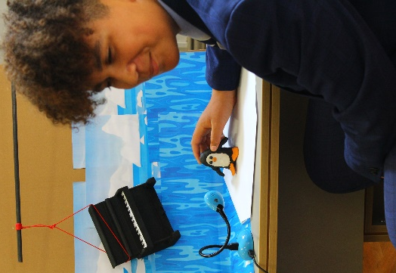
The UTC has a set of stop-motion animation cameras. Students work in groups to script and storyboard a short animated film. Students are given free reign over the nature of the film and the materials used. A high proportion (presumably inspired by Nick Park and Wallace and Gromit) choose the medium of plasticine. Having completed their filming, students are then required to use video editing software to link and edit the scenes, add titles and a soundtrack. This is a team activity, typically taking 10 hours.

Touch typing
In many professional jobs a high proportion of the working day is likely to be spent on a computer, writing letters, emails, reports and design briefs. Two finger typing, constantly looking at the keyboard is slow and inefficient. Students are given the opportunity, during project time to practice touch typing.

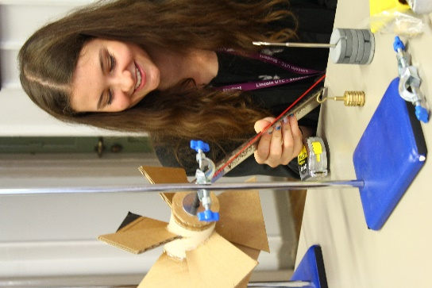
Wind turbines
Students work in teams competing in a wind turbine design challenge. There are two aspects to the competition. Points are awarded for the wind turbine which, when connected to a pulley, can raise the largest mass. Points are also awarded for the turbine which is capable of lifting a small mass (100g) at the greatest velocity. Most designs will be good at one or the other. The challenge for students is to create one machine that can do well in both competitions. Students are restricted in the choice of building materials. The wind source is a bouncy castle fan. The wind turbines are made from corrugated cardboard. Students are supplied with a selection of plastic tubes, metal bars, bolts, washers and bearings. Students start by researching different design options. They then choose a basic design approach and choose one variable to investigate and optimise. They might, for example, choose to investigate the pitch or angle of the blades on a fan. Some students will then make five or more different turbines with different angles in order to quantitatively evaluate them. Others will make one turbine on which the angles (or other variables) can be altered between trials. This project is about being systematic in approaching a quantitative investigation, with clear parallels to the students’ work in science. Teams of three, typically 10 hours.

Can crusher
A crowbar is perhaps one of the simplest ‘machines’ that you can have. It may be simple but it is effective in generating large forces. ‘Mole’grips, bolt cutters, G cramps and scissor jacks utilise the principles of levers and combine several different types of force magnifiers to perform their function and can generate massive forces. If you look closely at any one of these they are both clever and elegant in their design. Students study and measure a wide variety of these tools, classifying them according to the type of lever and then quantitatively measuring the magnitude of the forces produced. Students then work to design and make a domestic waste or can crushing machine. (10 hours to include the manufacture of a working prototype)

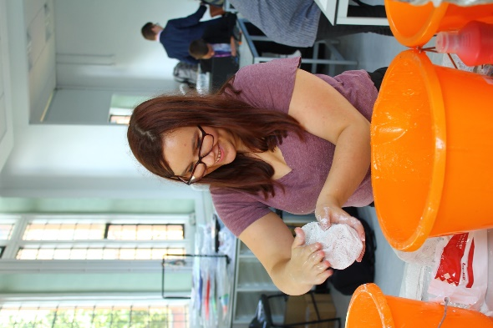
Art for Art’s sake
The best engineering isn’t just about the physical performance of the product. The best engineers design and make products which are also beautiful to behold. All students are given an opportunity in project time to explore a creative or artistic discipline. Students can choose from modelling and sculpture, watercolour painting, print making or digital photography. Students will spend between four and six sessions (10 to 15 hours) working on their piece of ‘art’. Whilst the time spent on this isn’t enough generally enough to master a discipline, mastery isn’t the objective. This is a project designed to be a taster … one in which students are just encouraged and allowed to be creative and ‘go with their muse’.

Theatre set design
All Key Stage 4 students are required to study two plays as part of their GCSE in English literature. The Shakespeare text they are studying is Romeo and Juliet. Students have to design and make accurate scale models of a theatre set for this play. Working through the set design and considering how it will change from scene to scene helps them to understand the chronology of the play…what happens in each scene and each act. It also requires them to engage with and understand the themes within the play and consider what the author is trying to convey and communicate at different points in the story.

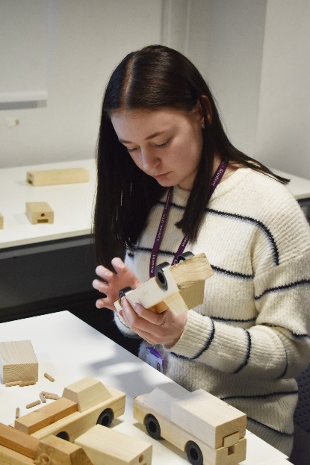
Ferry Loading
This is, for most students, a single project session (two and a half hours). Students start by playing a simple child’s toy puzzle (traffic jam). They then move on to a more challenging puzzle, manufactured here at the UTC by some of our students … ‘Ferry Loading’. The idea is simple. If you’re loading a ferry you don’t put all the HGV lorries on one side. You would try to balance the load. Students have a variety of different sized ‘vehicles’ (wooden blocks) of differing mass. They have to load a six lane ‘ferry’ keeping it balanced at all times. The idea may be simple but solving the puzzle is far from simple. This problem requires students to apply knowledge and skills from both the maths and physics specifications. The wooden block puzzle is flawed due to the fact that the knotty pine used doesn’t have uniform density, affecting the centre of mass. They are also not very convincing as cars and lorries. Some students have gone on to produce a better version of the game (as a marketable product) which overcomes the flaws in the prototype.

Cardboard furniture
Cardboard can be surprisingly strong and versatile as a building material and as an alternative to wood in the design and manufacture of furniture. A replica of Frank Gehry’s famous ‘wiggle chair’ could set you back over £700. Whether it is a bookcase, a chair or a chaise longue the design and manufacture of cardboard furniture presents both aesthetic and structural challenges. It requires a lot of thought and understanding about form and function. Students are given free choice over what item of furniture the wish to design. Initially, students will make small scale model prototypes as proof of concept (160gsm card 1/10 scale) before selecting the best models to scale up in heavy card.

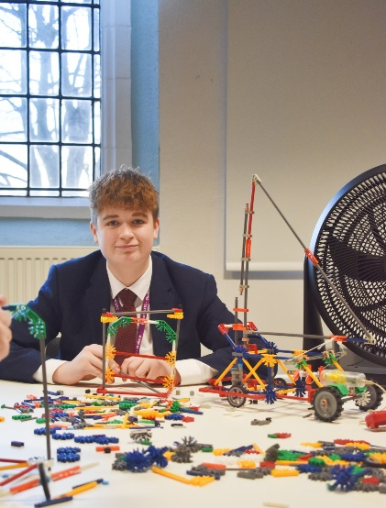
K’NEX land yacht
The physics of sailing is complex and challenging. A yacht can sail into the wind. A yacht can also sail faster than the wind. It is not the case that the wind simply pushes the sail and the boat forward. Trimming the sail so that the air flow is different on either side of the sail creates a pressure differential that, much like the forces acting on an aeroplane, drives the yacht forward (Bernoulli principle), It is an intricate balancing act of dimensions, angles and forces. Working in teams, students have to design and build a K’NEX land yacht that has a boom which can be operated and moved with a small remote controlled battery powered motor. Students have to research the design and the operation of sails on real yachts and then try to recreate that on their K’NEX model. Having built their models, the teams then compete in a range of races and ‘nautical’ agility challenges.

Excel Master
Microsoft Excel has to be one of the most widely used tools, in business, in industry and in engineering. Most people don’t even scratch the surface of what Excel can do or can be used for. In project time, students are given realistic scenarios with business data covering manufacturing and component costs, customer and sales data, supplier data, lead times and shipping costs. They are then set a number of analytical tasks and taught how to design spreadsheets which can carry out this analysis for them.

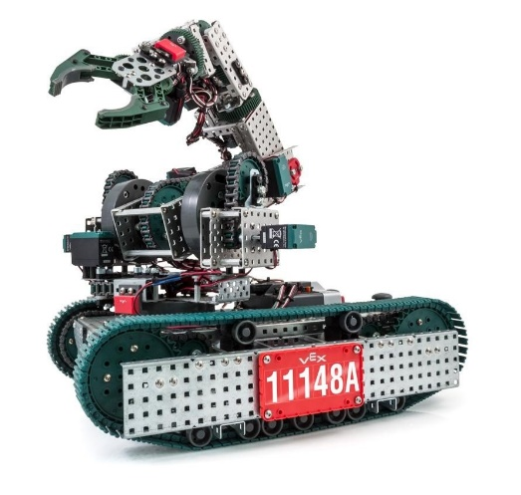
VEX Robotics Challenge
Lincoln UTC has an extensive range of VEX Robotics kit and components. The VEX kit is highly versatile. In its simplest form it can be used to create a simple remote control vehicle. As the students grow in confidence and skill they can take this further and download software onto the robot’s cpu allowing them to programme their robot to perform complex tasks and to have an ‘awareness’ of its surroundings. The ‘entry level’ challenge for the students is to design a robot that can compete in a game of ‘football’ with other teams. The more advanced students will design, build and programme a robot that is capable of independently navigating a pre-programmed course sensing and avoiding obstacles in its path. Students typically work in teams of four on this project and will spend 10 hours on this challenge.

PowerPoint Master
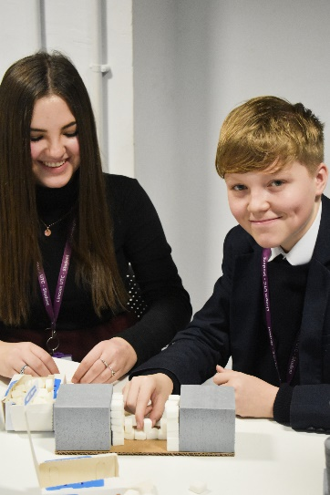
Most people will have sat through and endured boring PowerPoint presentations in which the presenter reads, verbatim, through interminable slides with bullet point after bullet point. ‘Clever’ transitions in which the new slide bounces in from the left do little to improve the experience. Actually, PowerPoint can be a versatile and powerful tool capable of doing so much more. In this project students are shown how to customise, create and design animations within PowerPoint. The scenario and the context for the students’ work is the creation of teaching aids for science (reinforcing and consolidating their learning in this subject). Students choose from a list of topics including, chemical reactions, DNA replication, and radioactive decay and then produce their own interactive animated presentations to explain the concepts to their peers.

Sugar cube building
A single session (two and a half hours). Students are provided with 250 sugar cubes and given a number of construction challenges such as arch and bridge building. Sugar cubes can be quickly and easily shaped with a craft knife or with sand paper. This is a competitive activity with points for bridge span and load bearing capacity.

Etch a Sketch
This challenge was inspired by a visit to one of our industry partners, Micrometric, who are a specialist laser manufacturing company (laser cutting and laser welding). In this industry, most of the processes are computer controlled. One of two things happens. Either the workpiece is stationary and the computer controls the movement of the laser or the laser is stationary and the computer controls the movement of the workpiece. In this project students attempt to replicate this control process. Student play a short game of battle ships (using grid coordinates). They are then asked to create a numerical code that would allow them to codify and communicate a two dimensional line drawing (inevitable based on either vectors and/or coordinates along with some sort of binary write/don’t write code). Having invented a coding language they work in pairs to test the language. Students then work in teams to design and build a simple machine which could convert their numerical code into a drawing. Some choose to go low tech using plywood, cog wheels and string. Some design their machines on computers and 3D print the component parts. Some have used our robotics components. ‘Failure’ rates are high on this project as, whilst the idea is simple, making the machine work definitely isn’t.

Call My Bluff (and other games)
Presentation skills and the ability to speak confidently in front of an audience are important for our students. These skills will be invaluable in most jobs and, for many students, important in helping them succeed in interview situations … to get the job in the first place. Many of the longer projects (design and build) require the students to make a presentation at the end, outlining the process they followed and their final product. Students also have sessions where they receive training and instruction on public speaking and presentations. Alongside this they also, on occasion, play ‘parlour games’ such as ‘Call My Bluff’. In this one, students work through dictionaries to select their own words and then either create alternative definitions or alternative etymological stories explaining the origin of the word. They then compete in teams

